ENGLISH  This half term, we will be reading Someone Just Like You to help us learn more about ourselves and others. Through a range of speaking, reading and writing activities, we will create a fact file all about ourselves and learn how to use labels, lists and captions effectively. We will develop our understanding of how to write correctly structured sentences and use capital letters accurately. By the end of the unit, we will create our own informative page that celebrates what makes us unique.  COMPUTING  We will explore Technology Around Us and learn about the different types of technology we use every day. We will identify computers and other digital devices, discuss their uses, and develop our understanding of how technology helps us at home, school and in the wider world.  SCIENCE  We will be locating and naming basic human body parts. We will then move on to learning about the five senses and the organs associated with each sense.  PE  This half term, PE lessons will take place on Thursday afternoons. Children will be introduced to structured movement through the topic of Everyday Life. They will learn how to move safely in a space, stop safely, share equipment and work independently, with a partner or as part of a group. Through a variety of simple games and activities, children will develop their movement skills and begin to understand and follow rules. | 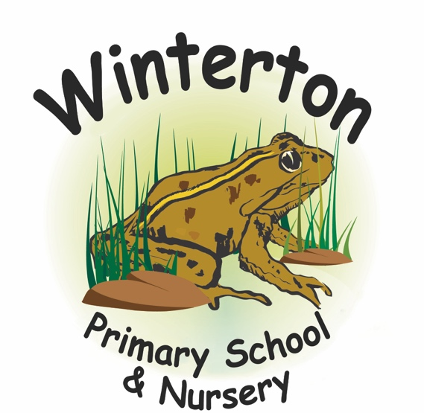  Starfish Class Curriculum Overview:  Autumn 1  Mrs Wells and Mrs Scott  SPELLING and READING  Please read at home with your child at least 5 times per week and record this in their reading record.  Pupils take part in 3 spelling lessons a week and we will be practising spelling in lessons at school. Within this time, children will become familiarised with high frequency words and common exception words.  HOMEWORK  At the beginning of each new half term, a homework menu of additional tasks is sent home with an end of term deadline. | MATHS  This half term, we will develop our understanding of place value within 20 by counting, ordering and comparing numbers, as well as representing them in different ways. We will build confidence with addition and subtraction within 20 using practical resources and number facts. Children will also explore the properties of 2D and 3D shapes, learning to identify, name and describe them using mathematical language.  ART  We will learn about the artist Wassily Kandinsky and explore how he used colours, shapes and lines to create abstract artwork. Children will experiment with a range of artistic techniques and materials to create their own Kandinsky-inspired pieces. We will develop our skills in drawing, painting and colour mixing while learning how art can be used to express ideas and emotions.  GEOGRAPHY  We will be answering the big question, ‘What makes our local area special?’ Children will explore the features of their local area and identify different types of houses and buildings. Through observation, discussion and simple map work, they will develop their understanding of the places where people live and the human features that make an area unique.  RE  In Autumn term, we will be thinking about the question ‘Why should I say sorry?’ We will be considering the viewpoints from different religions around the concept of sorry.  PSHE  we will be exploring the topic ‘Who Am I?’ and thinking about what makes each of us special and unique. Children will learn about different types of families and the important people in their lives. Through stories, discussions and activities, we will celebrate similarities and differences, develop respect for others, and build confidence in talking about ourselves and our feelings.

