ENGLISH  This half term, we will start off by reading Arthur and the Golden Rope. We will use this to learn what a graphic novel is, and the impact images can have on a reader. We will learn the features of a graphic novel and practise these skills, incorporating them into our own writing where we create the next scene for the story. We will then move onto persuasive speech and end the half term with a free verse poem. Within our writing, we will be focusing on adding detail to expanded noun phrases, using pronouns effectively and punctuating speech correctly. To enhance our written work, we will spend time rehearsing our thoughts orally within the units.  COMPUTING  This half term, we will be completing a data and information unit. We will specifically be looking at pictograms. We will be learning what pictograms are, how to read and interpret them and how to create our own using software.  SCIENCE  In science, we will be answering the big question ‘Could all animals live in the same habitat?’. We will be learning about and comparing different habitats and the animals and plants that live in those habitats. We will look at the adaptations different plants and animals have made to survive in their habitat.  PE  This half term, we will be playing netball. We will be learning the rules of the game and improving our teamwork skills. We will practice our throwing and catching skills, learning a range of different passes used within netball. | 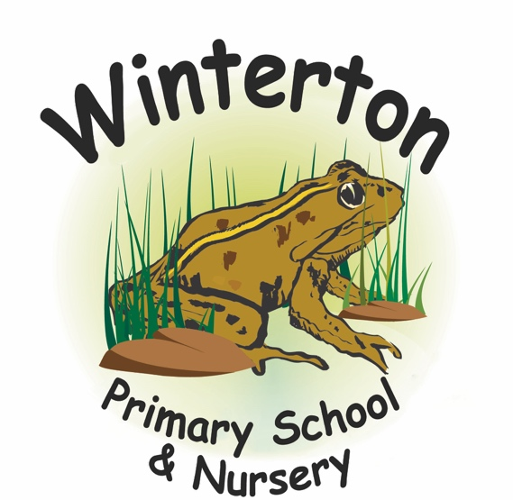  Year 3 Curriculum Overview:  Autumn 1  Mrs Scott and Miss Hall  SPELLING and READING  Please read at home with your child at least 5 times per week and record this in their reading record.  Pupils take part in 3 spelling lessons a week and we will be practising spelling in lessons at school. Within this time, children will become familiarised with high frequency words and common exception words.  HOMEWORK  At the beginning of each new half term, a homework menu of additional tasks is sent home with an end of term deadline. | MATHS  This half term, we will revisit number and place value. We will be using dienes and place value charts to deepen our knowledge of number and begin to partition larger numbers. We will also begin our addition and subtraction unit where we will be practising arithmetic methods to secure our understanding and enable us to add and subtract bigger numbers.  ART  In art, we will be creating a collage taking inspiration from Megan Coyle. We will firstly learn about Megan Coyle and her artwork, practise collage techniques, plan our work and then create our own artwork.  GEOGRAPHY  In Geography we will be learning about the continents and oceans. We will learn the names of them and where they are on the map. We will look at the different continents, naming some of the countries within them and comparing their climate. We will be using geographical vocabulary to describe where they are in the world.  RE  In RE, we will be answering the question ‘Why should I say sorry?’. We will be thinking about our actions having consequences and be able to explain why  saying sorry is important for repairing relationships and  restoring fairness. We will also look at the bible story ‘Jonah and the Whale’.  PSHE  In PSHE, our topic is Respectful Relations. We will learn what it means to be respectful, how our actions affect others and what to do if we are not treated with respect ourselves.

