ENGLISH  This half term, we will be reading Someone Just Like You to help us learn more about ourselves and others. Through a range of speaking, reading and writing activities, we will create a fact file all about ourselves and learn how to use labels, lists and captions effectively. We will develop our understanding of how to write correctly structured sentences and use capital letters accurately. By the end of the unit, we will create our own informative page that celebrates what makes us unique.  COMPUTING  This half term, we will be completing a data and information unit. We will specifically be looking at pictograms. We will be learning what pictograms are, how to read and interpret them and how to create our own using software.  SCIENCE  In science, we will be answering the big question ‘Could all animals live in the same habitat?’. We will be learning about and comparing different habitats and the animals and plants that live in those habitats. We will look at the adaptations different plants and animals have made to survive in their habitat.  PE  This half term, we will be playing netball. We will be learning the rules of the game and improving our teamwork skills. We will practice our throwing and catching skills, learning a range of different passes used within netball. | 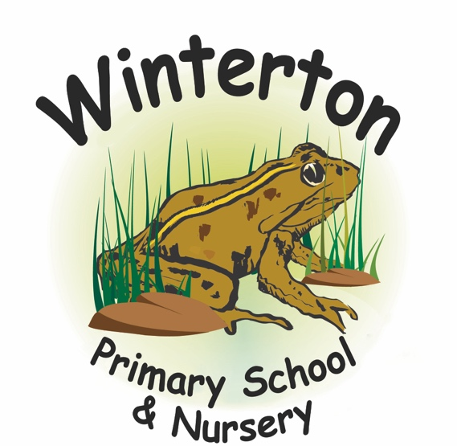  Year 2 Curriculum Overview:  Autumn 1  AM: Mrs Wells and Mrs Scott  PM: Mrs Scott and Miss Hall  SPELLING and READING  Please read at home with your child at least 5 times per week and record this in their reading record.  Pupils take part in 3 spelling lessons a week and we will be practising spelling in lessons at school. Within this time, children will become familiarised with high frequency words and common exception words.  HOMEWORK  At the beginning of each new half term, a homework menu of additional tasks is sent home with an end of term deadline. | MATHS  This half term, we will develop our understanding of place value within 20 by counting, ordering and comparing numbers, as well as representing them in different ways. We will build confidence with addition and subtraction within 20 using practical resources and number facts. Children will also explore the properties of 2D and 3D shapes, learning to identify, name and describe them using mathematical language.  ART  In art, we will be creating a collage taking inspiration from Megan Coyle. We will firstly learn about Megan Coyle and her artwork, practise collage techniques, plan our work and then create our own artwork.  GEOGRAPHY  In Geography we will be learning about the continents and oceans. We will learn the names of them and where they are on the map. We will look at the different continents, naming some of the countries within them and comparing their climate. We will be using geographical vocabulary to describe where they are in the world.  RE  In RE, we will be answering the question ‘Why should I say sorry?’. We will be thinking about our actions having consequences and be able to explain why  saying sorry is important for repairing relationships and  restoring fairness. We will also look at the bible story ‘Jonah and the Whale’.  PSHE  In PSHE, our topic is Respectful Relations. We will learn what it means to be respectful, how our actions affect others and what to do if we are not treated with respect ourselves.

