Seal Class Homework Menu – Autumn 1
Over the next half term please complete at least 4 pieces of work from the homework menu.
All homework due in the week beginning 19th October for homework presentations.
  In P.S.H.E. we are learning about our mental wellbeing. Create a diary of your emotions. You could also add any strategies you’ve used to help to regulate your emotions. | 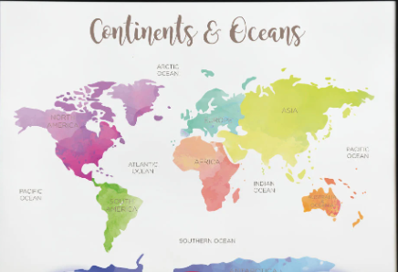  In Geography our topic is the 7 continents and 5 oceans. Research one continent and make a poster with all the information you can find out about it. | In Science we have been learning about habitats. Pick one we have been learning about or one of your own and create a habitat poster or model. You can be as creative as you like! Include drawings, photos or models of the animals and some facts about the habitat.
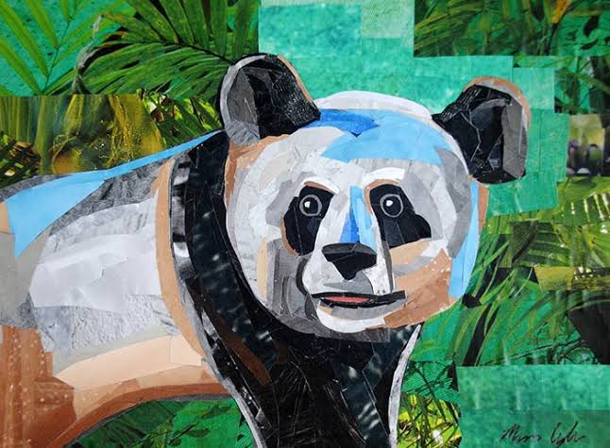  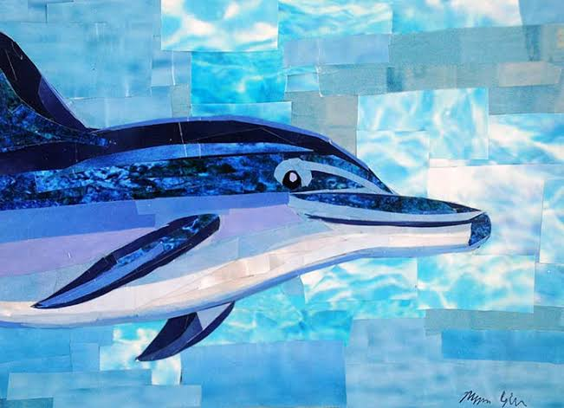  We are learning about the artist Megan Coyle. Recreate one of her collages, or create your own collage. | An idea of your own…   | 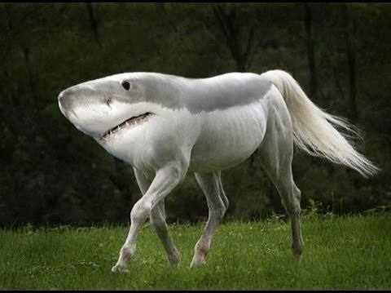  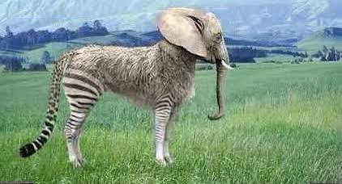  Invent your own animal and pick a habitat for it to live in. Label and describe the adaptations that make it suitable to live in that chosen habitat?
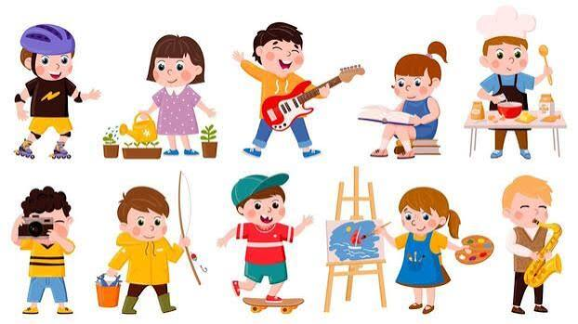  Write about your favourite activity. You could explain why you like doing it, when you do it, and who you do it with. | Reading for Pleasure:    YOU are a reader.  As well as books,  what and where  can you read? | Practise your 2, 5 and 10 times tables.    Write them out and then get a grown up or friend to test you. How many can you get correct?

