ENGLISH  This term our English will be focusing creative writing inspired by Matilda and the character of Miss Trunchbull. We will be writing information texts and narrative exploring how to convey character through dialogue and mannerisms. We will also be using Ancient Egyptian mummification as a stimulus to write a set of instructions.  COMPUTING  Our computing unit this term will be focused on developing skills using Excel to use formula and draw charts.  SCIENCE  This term, our science topic is Food and Food Chains. We will explore the different types of teeth and how to keep them healthy before identifying and constructing food chains & webs.  PE  In PE this term, the Sharks will be focused on developing improving our netball skills.  PSHE  The theme of our PSHE topic this term is focused on families. |  | 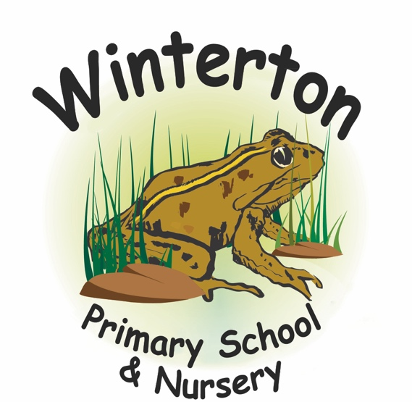  Shark Class Curriculum Overview: Autumn 1  Year 5 & 6  Miss Bane  READING & TTRS  Reading with your child is proven to improve their outcomes. Please try and read with your child 5 x a week and write in their reading record.  Two minutes a day, 5 times a week using Times Tables Rock Star can have a huge impact on your child’s mathematics. Please encourage frequent use of this program. |  | MATHS  In maths this half term we will be developing further skills with number and place value and the four operations ready for the year ahead. We will be focused on securing fluency and accuracy with the four operations in preparation for the end of KS2.  ART & DESIGN  This term, our Art and Design unit is a study of the artist Joel Penkman. We will appraise her work and make our own observational drawings of biscuits. Following this, we will experiment with watercolours, acrylics and clay to recreate biscuits in her style.  HISTORY  This term, our history unit focuses on the Ancient Egyptians. We will consider the importance of the Nile, how society was ordered, ruling Pharaohs, achievements & inventions and identify the cause of the civilisations end.  RE  In RE this term, we will consider the importance of storytelling across key world religions.

