Shark Class Homework Menu – Autumn 1
Here are ideas to inspire you to continue your learning outside of school – be as creative as you want.
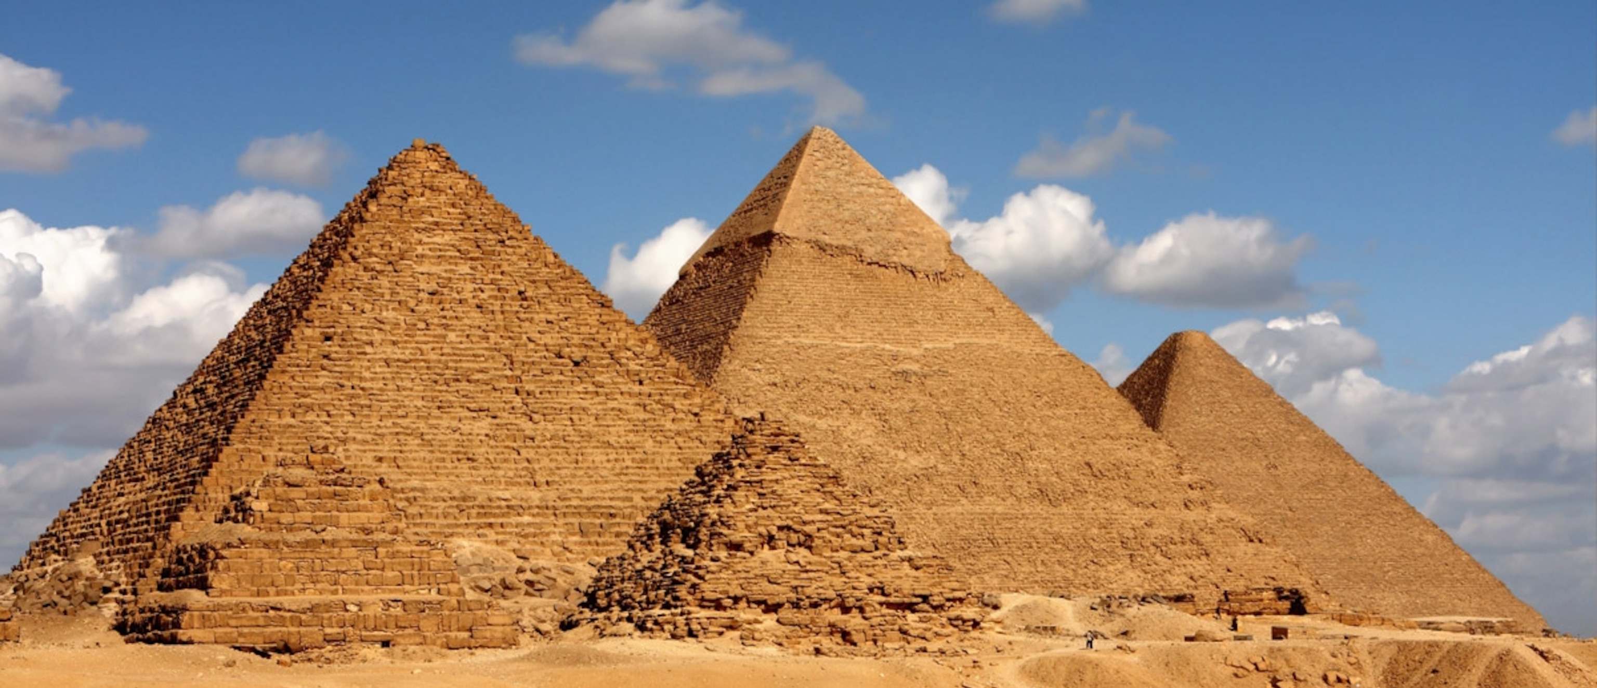  There is so much more to know about Ancient Egypt than we can't fit into a term – what more can you learn?  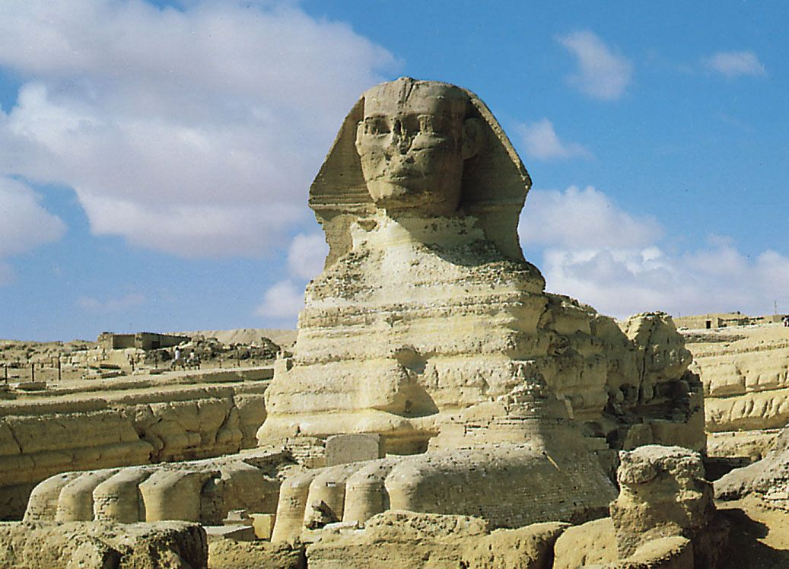  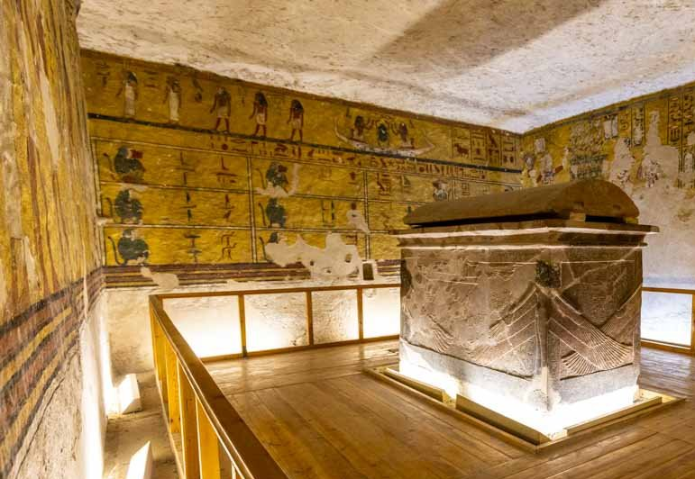  Ask Miss Bane for a place to start! |  | 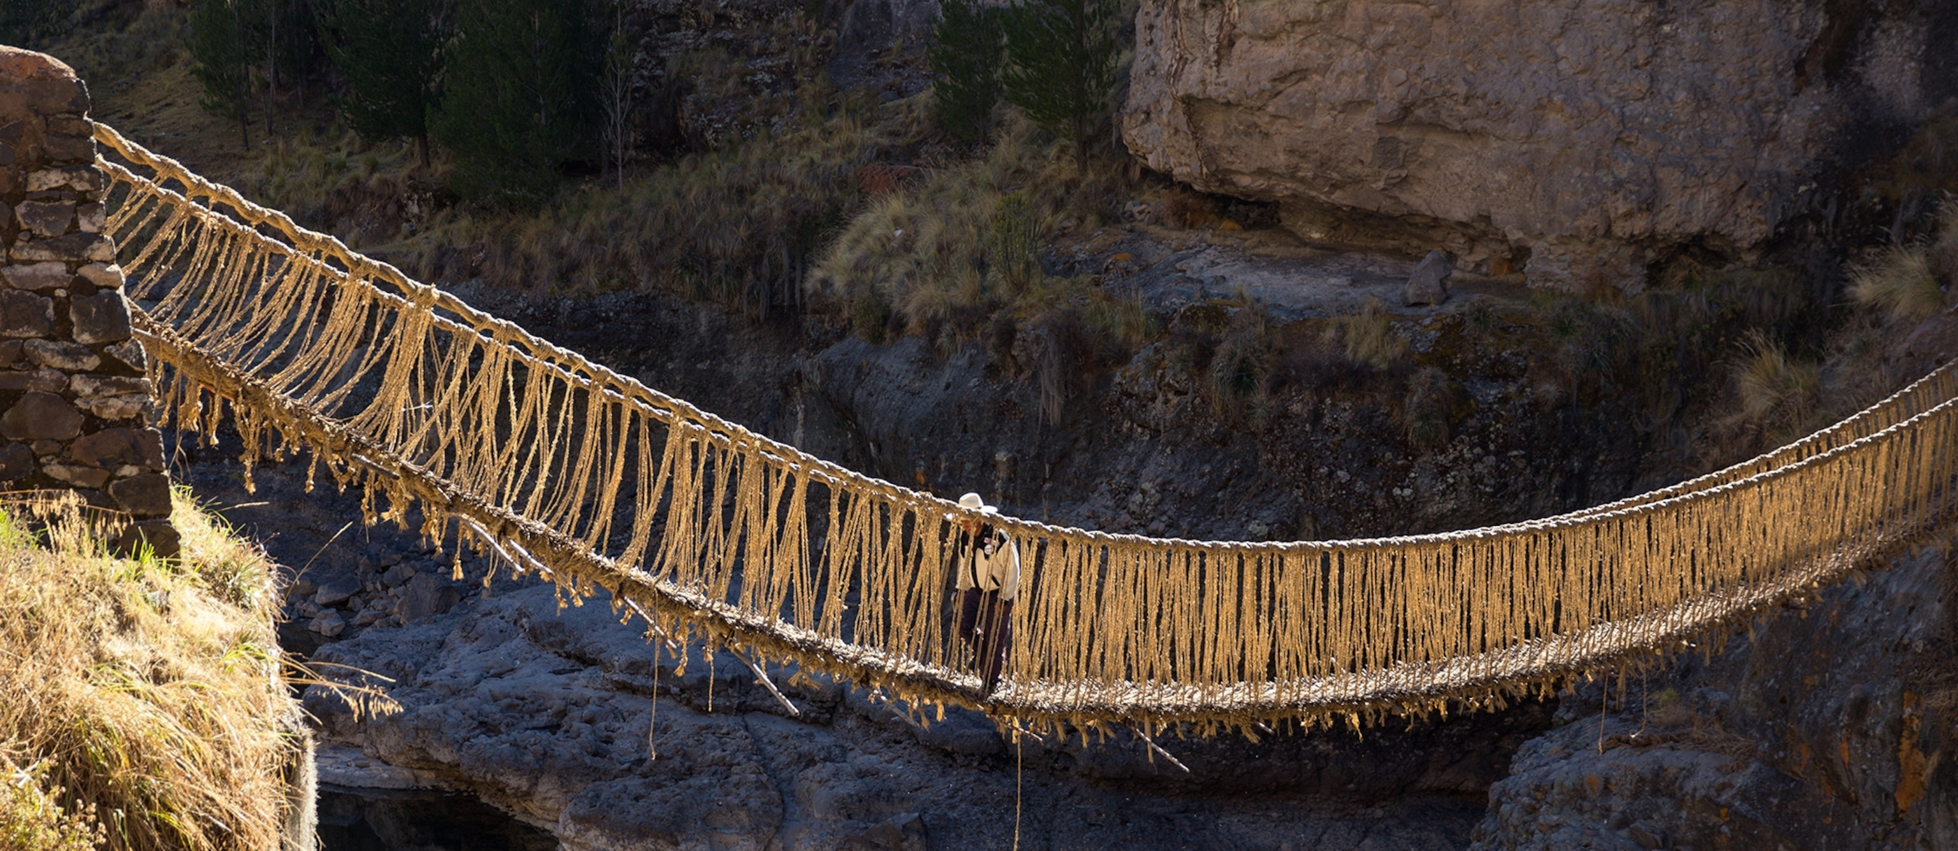    There are so many other ancient civilisations to explore – find out more..  Visit the Incas, the Aztecs or Mayans |  | 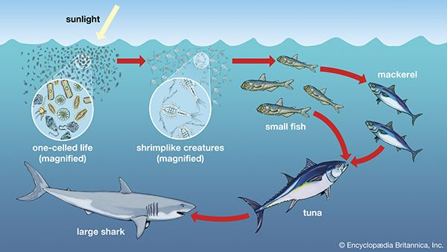  Can you create a food chain or web for your own animals or ecosystem?
 |  | An idea of your own…   |  | 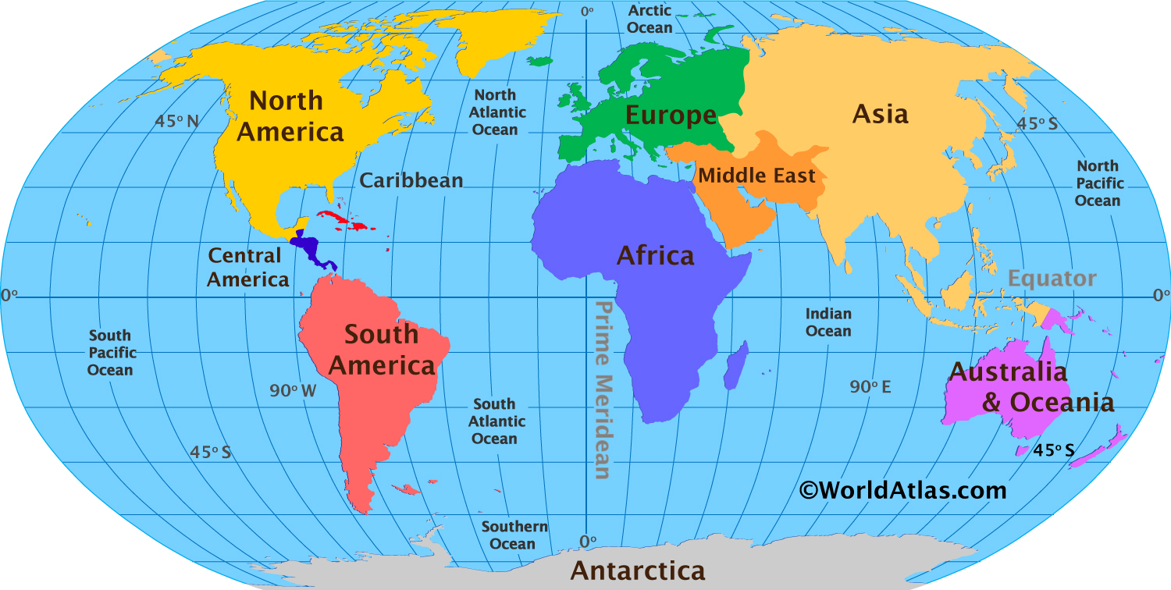  Find out about a part of the world that interests you – it could be a continent, country or our local area.
Be inspired by other food artists like Wayne Thiebaud and Lisa Milroy.  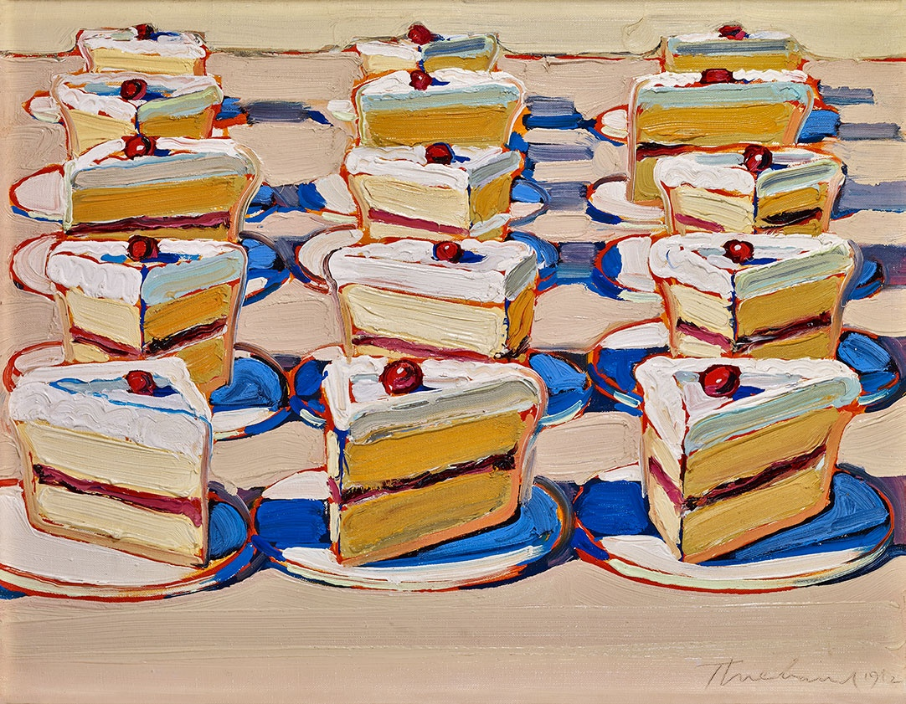  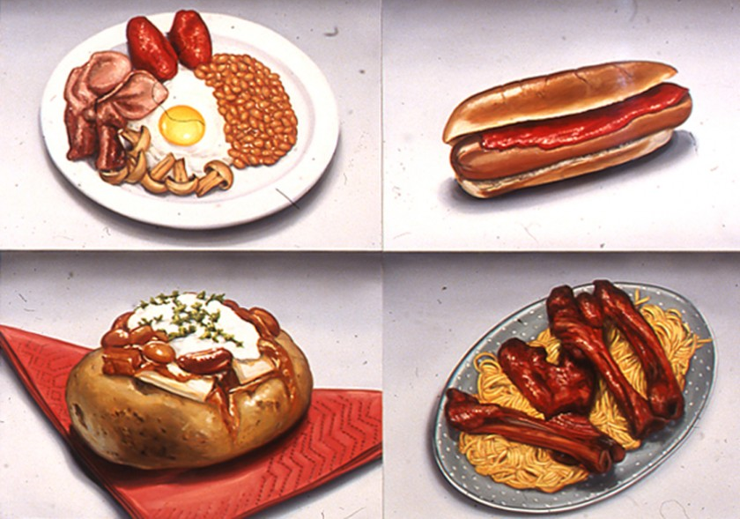 | What are you reading? Discover something new in non-fiction or a whole new world in fiction. Share your reding with us.  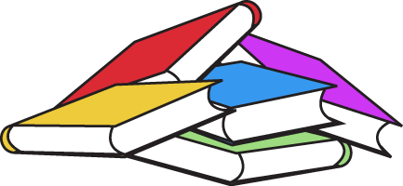 |  |  | 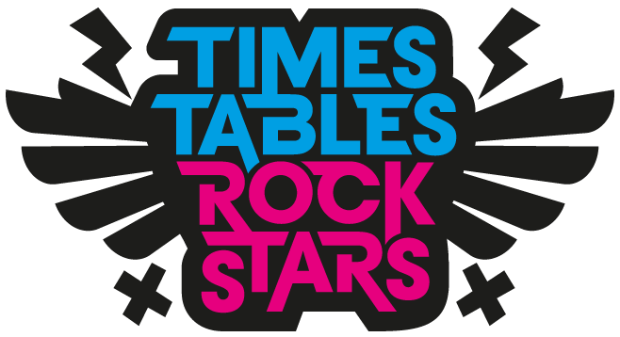  Will you Go Green  or improve your  Rock Status?  Spend some time on TTRS.
Over the half term please complete at least  4 pieces of work from the homework menu. |  |  | All homework due in the week beginning  12th October for presenting to the class.

