 |  | 

Winterton Primary School and Nursery

Safeguarding Information

We treat child protection seriously at our school. If you have any concerns regarding the wellbeing of any child, please speak immediately to one of our Safeguarding Officers as indicated below.
School Safeguarding Officers
  Mrs Hannah Waters  Assistant Academy Head/DSL  h.waters@consortiumtrust.org.uk  Tel: 01493 393218 |  |  | 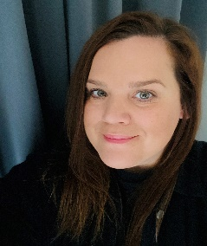  Miss Jemima Williams  Academy Head/ADSL  j.williams@consortiumtrust.org.uk  Tel: 01493 393218 |   Mrs Melanie Saunders  Office Manager/ADSL  m.saunders@consortiumtrust.org.uk  Tel: 01493 393218
Trust Safeguarding Officers
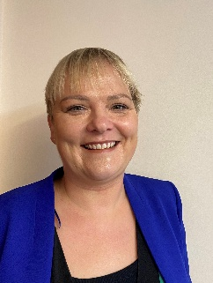
 
Mrs Debbie Thomas Mrs Lisa Jones Mrs Joanna Lawrence
Director of Primary Education Director of Finances and Resource Head of Service- Culture,
Attendance & Safeguarding/ Trust DSL

d.thomas@consortiumtrust.org.uk l.jones@consortiumtrust.org.uk j.lawrence@consortiumtrust.org.uk Tel: 01473 355453 Tel: 01473 355537 Tel: 01473 355412

 | Mr Andrew Aalders-Dunthorne  CEO  a.aalders-dunthorne@consortiumtrust.org.uk  Tel: 01473 355389 |  | Mrs Sue Child  Safeguarding Trustee  s.child@consortiumtrust.org.uk
If for any reason the above officers cannot be reached, referral forms can be downloaded from the Norfolk Safeguarding Children Partnership at https://www.norfolklscb.org/ or by contacting them on 0344 800 8020
All school staff have completed Prevent Online Channel Awareness Training

