Safeguarding Statement
We are committed to safeguarding and promoting the welfare of children. We expect all staff, volunteers, and visitors to share this common commitment. This leaflet contains information about our expectations of you whilst visiting the school. If you are unclear about anything in it please speak to any of the contacts named within. Please keep the leaflet in a safe place so that you can read it again if you need to.
If you are concerned about the safety of any child in our school, you must report this to one of the Designated Safeguarding Leads (DSL).
If you are concerned about the conduct of a member of staff or volunteer in your school (Allegations against Staff / Whistleblowing Policy), you must contact the Academy Head (Jemima Williams).
Photographs and Mobile Phones
The use of personal phones by anyone is not permitted. Our approach to online safety is based on addressing the following categories of risk:
- Content – being exposed to illegal, inappropriate, or harmful content.
- Contact – being subjected to harmful online interaction with other users, such as peer-to-peer.
- Conduct – personal online behaviour that increases the likelihood of, or causes, harm, such as making, sending, and receiving explicit images.
- Commerce – risks such as online gambling, inappropriate advertising, phishing and/or financial scams
Visitor Procedures
All visitors must sign in at the main reception.
- All visitors will be issued with a visitors sticker which must always be displayed whilst on the site
- Visitors will be asked to remain under the supervision of a designated member of staff whilst on site
- All visitors must sign out at the main reception before leaving the site
- Visitors wishing to see a member of staff should contact the school to make an appointment. If you are seeking an urgent appointment, please report to the school office and we will arrange for you to see a member of staff
Health and Safety
Fire:
In the event of a fire alarm please use the nearest fire exit and make your way to the evacuation point at back of the playing field. Please make yourself aware of the nearest fire exit to where you are based.
Keeping Yourself Safe
- Be professional.
- Avoid physical contact with children unless you are preventing them from immediately harming themselves or others.
- Always tell someone if a child touches you or speaks to you inappropriately. Log down the incident, time, and date it and pass it on to one of the Safeguarding Team.
- If you have concerns about the conduct of staff, it is your responsibility to inform the Academy Head.
Remember...if in doubt...ask

Please return your visitor sticker at the end of your visit.
Safeguarding is Everyone’s Responsibility


Winterton Primary School and Nursery

A Guide to Safeguarding for all Visitors and Volunteers



Telephone: 01493 393218
Email: office.winterton@consortiumtrust.org.uk

Designated Safeguarding Leads

Jemima Williams – Academy Head
Email: j.williams@consortiumtrust.org.uk
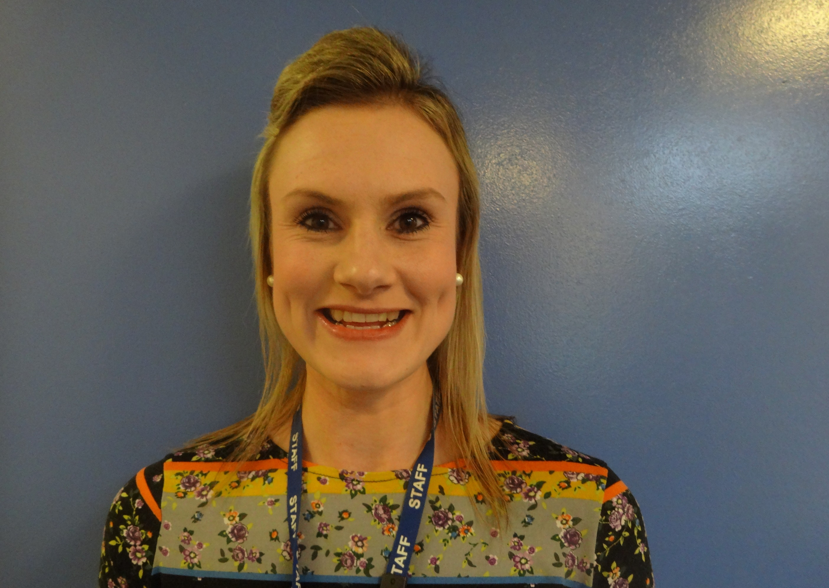

Hannah Waters - Assistant Academy Head/SENDCo
Email: h.waters@consortiumtrust.org.uk

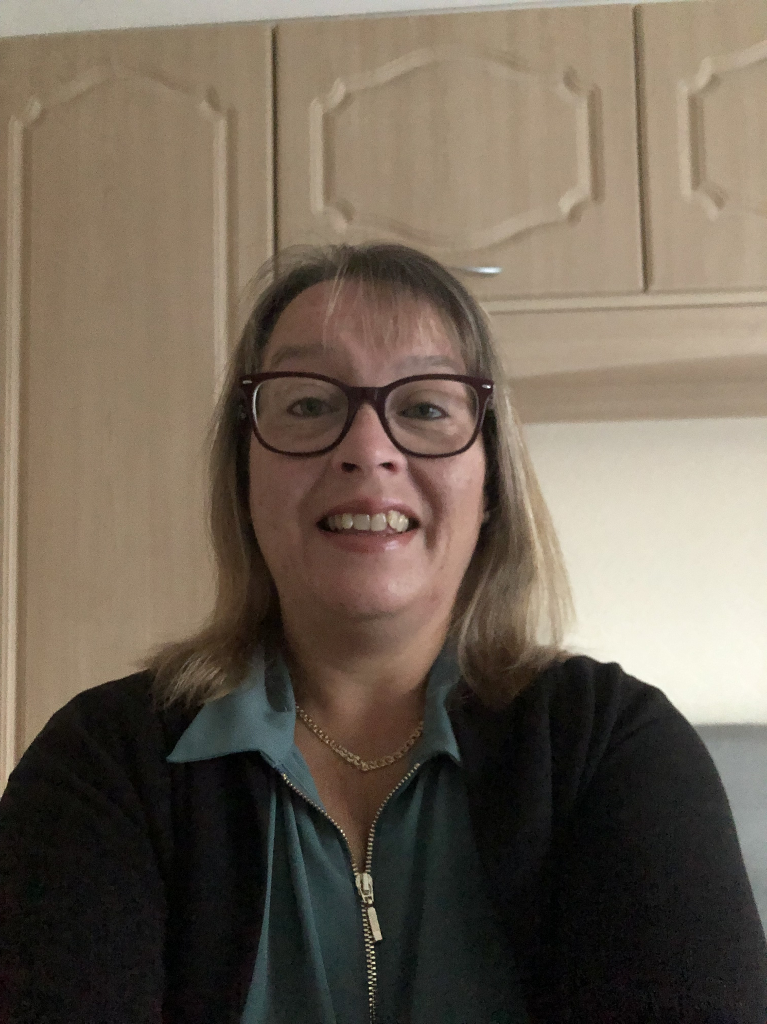

Melanie Saunders – Office Manager
Email: m.saunders@consortiumtrust.org.uk



Sue Childs
Trust Safeguarding DSL
Email s.childs@consortiumtrust.org
WHISTLEBLOWING
The Whistle-blowing reports wrongdoing that it is “in the public interest” to report. Examples linked to safeguarding include:
- Pupils’ or staff’s health and safety being put in danger.
- Failure to comply with a legal obligation or statutory requirement.
- Attempts to cover up the above, or any other wrongdoing in the public interest.
- Staff are encouraged to report suspected wrongdoing as soon as possible. Their concerns will be taken seriously and investigated, and their confidentiality will be respected.
Staff should consider the examples above when deciding whether their concern is of a whistleblowing nature. Consider whether the incident(s) was illegal, breached statutory or school procedures, put people in danger or was an attempt to cover any such activity up.

DRESS POLICY
All members of staff are expected to take a sensible and safe approach to dress and appearance, cleanliness, and personal hygiene. All footwear must be fully enclosed to protect from injury that could be caused by wheelchairs, walking frames, built up
shoes and splints. Avoid the wearing of jewellery, such as necklaces and earrings that can be hazardous, especially when these can get caught or pulled. Use of false fingernails and long nails are discouraged in all settings. Tattoos on the face or visible above the collar are not permitted. To retain a professional image, where feasible, all other tattoos should be covered.

RECOGNISING CONCERNS - SIGNS & INDICATORS OF ABUSE
All staff should be aware that abuse, neglect and safeguarding issues are rarely standalone events that can be covered by one definition or label.
- Abuse: a form of maltreatment of a child. Somebody may abuse or neglect a child by inflicting harm or by failing to act to prevent harm. Harm can include ill treatment that is not physical as well as the impact of witnessing ill treatment of others.
- Physical abuse: a form of abuse, which may involve hitting, shaking, throwing, poisoning, burning or scalding, rowing, suffocating or otherwise causing physical harm to a child.
- Emotional abuse: the persistent emotional maltreatment of a child such as to cause severe and adverse effects the child’s emotional development.
- Sexual abuse: involves forcing or enticing
a child or young person to take part in sexual activities, not necessarily involving violence, whether the child is aware of what is happening.
If you feel that a child may be at risk of harm but are not sure, please go to the school office and get a form “Appendix B – for use by Supply staff, visitors and exceptional circumstances.” Then inform one of the Safeguarding Leads immediately. They will offer advice and take appropriate action.
Child abuse can happen to any child regardless of elements such as gender, culture, religion, social background, ability of disability.

